1.Design a login page?

XML CODE

<LinearLayout
android:layout_width="match_parent"
android:layout_height="match_parent"
android:orientation="vertical"
xmlns:android="http://schemas.android.com/apk/res/android">
<TextView
android:layout_height="wrap_content"
android:layout_width="wrap_content"
android:id="@+id/tv1"
android:text="Username"/>
<EditText
android:layout_width="wrap_content"
android:layout_height="wrap_content"
android:id="@+id/et1"/>
<TextView
android:layout_width="wrap_content"
android:layout_height="wrap_content"
android:id="@+id/tv2"
android:text="Password"/>
<EditText
android:layout_width="wrap_content"
android:layout_height="wrap_content"
android:id="@+id/et2"
/>
<Button
android:layout_width="wrap_content"
android:layout_height="wrap_content"
android:id="@+id/b1"
android:text="Login"/>
<Button
android:id="@+id/b2"
android:layout_width="wrap_content"
android:layout_height="wrap_content"
android:text="Cancel" />
</LinearLayout>
Output
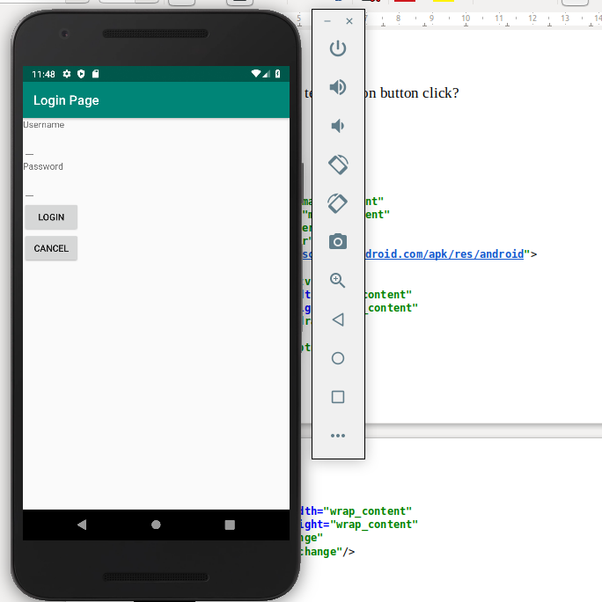
2.Change the content in the textview on button click?

XML CODE:

<LinearLayout
android:layout_width="match_parent"
android:layout_height="match_parent"
android:orientation="vertical"
android:gravity="center"
xmlns:android="http://schemas.android.com/apk/res/android">
<TextView
android:id="@+id/tv"
android:layout_width="wrap_content"
android:layout_height="wrap_content"
android:text="Sandra"/>
<Button
android:id="@+id/btn1"
android:layout_width="wrap_content"
android:layout_height="wrap_content"
android:text="Change"
android:onClick="change"/>
</LinearLayout>
JAVA CODE
public class MainActivity extends AppCompatActivity {
TextView tv;
@Override
protected void onCreate(Bundle savedInstanceState) {
super.onCreate(savedInstanceState);
setContentView(R.layout.activity_main);
tv = findViewById(R.id.tv);
}
public void change(View view) {
tv.setText("Essa");
}
}
Output

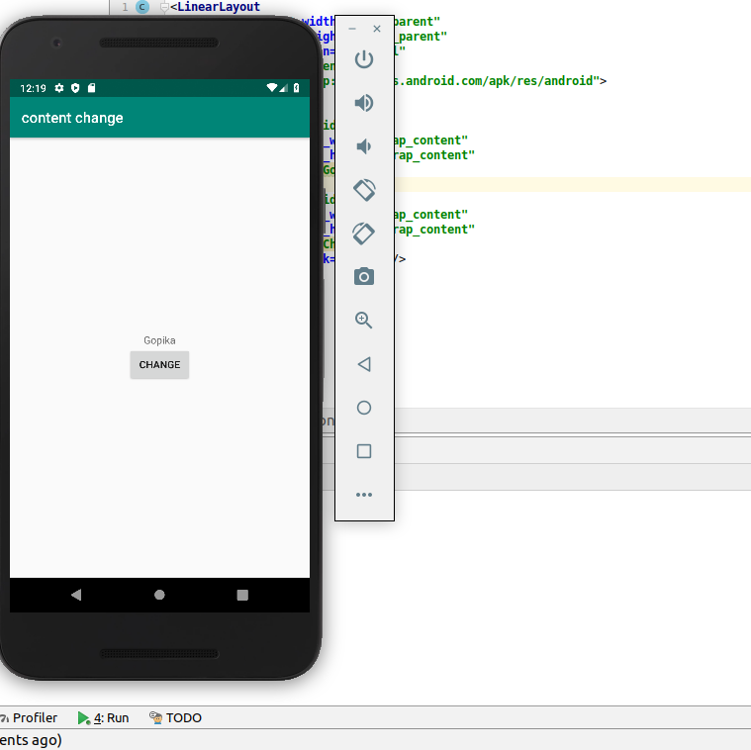

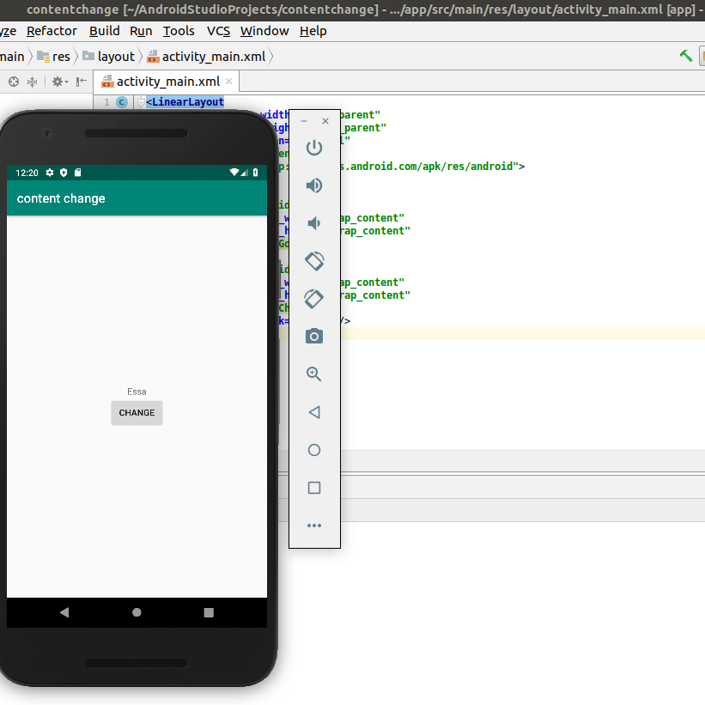
3.Read a content from edit text and print it in a textview?

XML CODE

<LinearLayout
android:layout_width="match_parent"
android:layout_height="match_parent"
android:orientation="vertical"
android:gravity="center"
xmlns:android="http://schemas.android.com/apk/res/android">
<TextView
android:layout_width="wrap_content"
android:layout_height="wrap_content"
android:id="@+id/tv"
android:text="Gopika"/>
<EditText
android:layout_width="wrap_content"
android:layout_height="wrap_content"
android:id="@+id/et"
android:hint="Enter Text"/>
<Button
android:layout_width="wrap_content"
android:layout_height="wrap_content"
android:id="@+id/btn"
android:text="Change TextView"
android:onClick="click"/>
</LinearLayout>
JAVA CODE

public class MainActivity extends AppCompatActivity {
TextView tv;
EditText et;
@Override
protected void onCreate(Bundle savedInstanceState) {
super.onCreate(savedInstanceState);
setContentView(R.layout.activity_main);
}
public void click(View view) {
tv = findViewById(R.id.tv);
et = findViewById(R.id.et);
tv.setText(et.getText());
}
}
Output
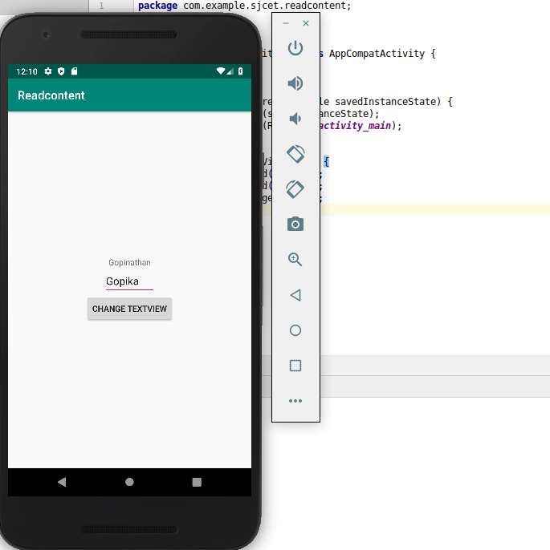

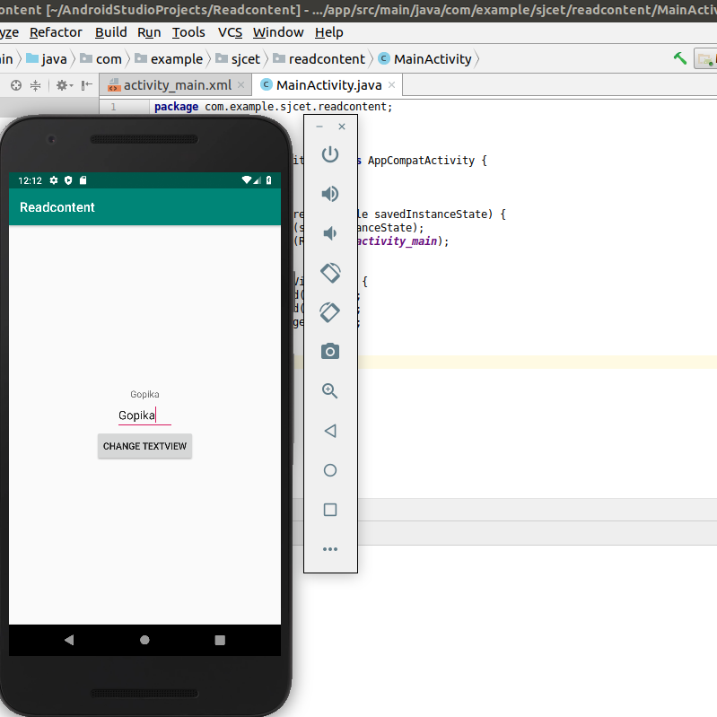

4.Change the background color on a button click

XML CODE

<LinearLayout
android:id="@+id/l1"
android:layout_width="match_parent"
android:layout_height="match_parent"
android:orientation="vertical"
android:gravity="center"
xmlns:android="http://schemas.android.com/apk/res/android" >
<Button
android:layout_width="wrap_content"
android:layout_height="wrap_content"
android:id="@+id/b1"
android:text="submit"
android:onClick="click"/>
</LinearLayout>
JAVA CODE

package com.example.sjcet.backgroundcolor;
import android.support.v7.app.AppCompatActivity;
import android.os.Bundle;
import android.view.View;
import android.widget.Button;
import android.widget.LinearLayout;
public class MainActivity extends AppCompatActivity {
protected void onCreate(Bundle savedInstanceState) {
super.onCreate(savedInstanceState);
setContentView(R.layout.activity_main);
Button button1;
final LinearLayout Layout;
Layout = findViewById(R.id.l1);
button1 = findViewById(R.id.b1);
button1.setOnClickListener(new View.OnClickListener() {
@Override
public void onClick(View view) {
Layout.setBackgroundResource(R.color.colorPrimaryDark);
}
});
}
}
OUTPUT

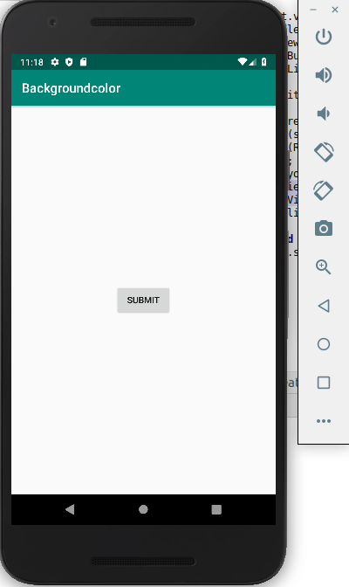

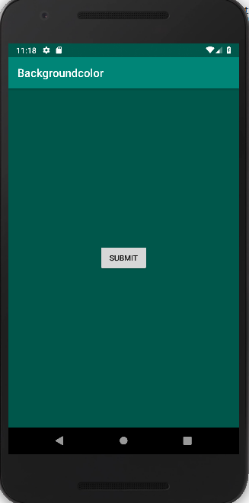

5.Create a sample calculator?

XML CODE
<RelativeLayout xmlns:android="http://schemas.android.com/apk/res/android"
xmlns:tools="http://schemas.android.com/tools"
android:id="@+id/relative1"
android:layout_width="match_parent"
android:layout_height="match_parent"
tools:context=".MainActivity">
<EditText
android:id="@+id/edt1"
android:layout_width="match_parent"
android:layout_height="wrap_content" />
<Button
android:id="@+id/button1"
style="?android:attr/buttonStyleSmall"
android:layout_width="wrap_content"
android:layout_height="wrap_content"
android:layout_alignEnd="@+id/button4"
android:layout_alignRight="@+id/button4"
android:layout_below="@+id/edt1"
android:layout_marginTop="94dp"
android:text="1" />
<Button
android:id="@+id/button2"
style="?android:attr/buttonStyleSmall"
android:layout_width="wrap_content"
android:layout_height="wrap_content"
android:layout_alignTop="@+id/button1"
android:layout_toLeftOf="@+id/button3"
android:layout_toStartOf="@+id/button3"
android:text="2" />
<Button
android:id="@+id/button3"
style="?android:attr/buttonStyleSmall"
android:layout_width="wrap_content"
android:layout_height="wrap_content"
android:layout_alignTop="@+id/button2"
android:layout_centerHorizontal="true"
android:text="3" />
<Button
android:id="@+id/button4"
style="?android:attr/buttonStyleSmall"
android:layout_width="wrap_content"
android:layout_height="wrap_content"
android:layout_below="@+id/button1"
android:layout_toLeftOf="@+id/button2"
android:text="4" />
<Button
android:id="@+id/button5"
style="?android:attr/buttonStyleSmall"
android:layout_width="wrap_content"
android:layout_height="wrap_content"
android:layout_alignBottom="@+id/button4"
android:layout_alignLeft="@+id/button2"
android:layout_alignStart="@+id/button2"
android:text="5" />
<Button
android:id="@+id/button6"
style="?android:attr/buttonStyleSmall"
android:layout_width="wrap_content"
android:layout_height="wrap_content"
android:layout_alignLeft="@+id/button3"
android:layout_alignStart="@+id/button3"
android:layout_below="@+id/button3"
android:text="6" />
<Button
android:id="@+id/button7"
style="?android:attr/buttonStyleSmall"
android:layout_width="wrap_content"
android:layout_height="wrap_content"
android:layout_below="@+id/button4"
android:layout_toLeftOf="@+id/button2"
android:text="7" />
<Button
android:id="@+id/button8"
style="?android:attr/buttonStyleSmall"
android:layout_width="wrap_content"
android:layout_height="wrap_content"
android:layout_alignLeft="@+id/button5"
android:layout_alignStart="@+id/button5"
android:layout_below="@+id/button5"
android:text="8" />
<Button
android:id="@+id/button9"
style="?android:attr/buttonStyleSmall"
android:layout_width="wrap_content"
android:layout_height="wrap_content"
android:layout_alignLeft="@+id/button6"
android:layout_alignStart="@+id/button6"
android:layout_below="@+id/button6"
android:text="9" />
<Button
android:id="@+id/buttonadd"
style="?android:attr/buttonStyleSmall"
android:layout_width="wrap_content"
android:layout_height="wrap_content"
android:layout_alignEnd="@+id/edt1"
android:layout_alignRight="@+id/edt1"
android:layout_alignTop="@+id/button3"
android:layout_marginLeft="46dp"
android:layout_marginStart="46dp"
android:layout_toRightOf="@+id/button3"
android:text="+" />
<Button
android:id="@+id/buttonsub"
style="?android:attr/buttonStyleSmall"
android:layout_width="wrap_content"
android:layout_height="wrap_content"
android:layout_alignEnd="@+id/buttonadd"
android:layout_alignLeft="@+id/buttonadd"
android:layout_alignRight="@+id/buttonadd"
android:layout_alignStart="@+id/buttonadd"
android:layout_below="@+id/buttonadd"
android:text="-" />
<Button
android:id="@+id/buttonmul"
style="?android:attr/buttonStyleSmall"
android:layout_width="wrap_content"
android:layout_height="wrap_content"
android:layout_alignLeft="@+id/buttonsub"
android:layout_alignParentEnd="true"
android:layout_alignParentRight="true"
android:layout_alignStart="@+id/buttonsub"
android:layout_below="@+id/buttonsub"
android:text="*" />
<Button
android:id="@+id/button10"
style="?android:attr/buttonStyleSmall"
android:layout_width="wrap_content"
android:layout_height="wrap_content"
android:layout_below="@+id/button7"
android:layout_toLeftOf="@+id/button2"
android:text="." />
<Button
android:id="@+id/button0"
style="?android:attr/buttonStyleSmall"
android:layout_width="wrap_content"
android:layout_height="wrap_content"
android:layout_alignLeft="@+id/button8"
android:layout_alignStart="@+id/button8"
android:layout_below="@+id/button8"
android:text="0" />
<Button
android:id="@+id/buttonC"
style="?android:attr/buttonStyleSmall"
android:layout_width="wrap_content"
android:layout_height="wrap_content"
android:layout_alignLeft="@+id/button9"
android:layout_alignStart="@+id/button9"
android:layout_below="@+id/button9"
android:text="C" />
<Button
android:id="@+id/buttondiv"
style="?android:attr/buttonStyleSmall"
android:layout_width="wrap_content"
android:layout_height="wrap_content"
android:layout_alignEnd="@+id/buttonmul"
android:layout_alignLeft="@+id/buttonmul"
android:layout_alignRight="@+id/buttonmul"
android:layout_alignStart="@+id/buttonmul"
android:layout_below="@+id/buttonmul"
android:text="/" />
<Button
android:id="@+id/buttoneql"
android:layout_width="wrap_content"
android:layout_height="wrap_content"
android:layout_alignEnd="@+id/buttondiv"
android:layout_alignLeft="@+id/button10"
android:layout_alignRight="@+id/buttondiv"
android:layout_alignStart="@+id/button10"
android:layout_below="@+id/button0"
android:layout_marginTop="37dp"
android:text="=" />
</RelativeLayout>
JAVA CODE
package com.example.sjcet.calculator;
import android.os.Bundle;
import android.support.v7.app.AppCompatActivity;
import android.view.View;
import android.widget.Button;
import android.widget.EditText;
public class MainActivity extends AppCompatActivity {
Button button0, button1, button2, button3, button4, button5, button6,
button7, button8, button9, buttonAdd, buttonSub, buttonDivision,
buttonMul, button10, buttonC, buttonEqual;
EditText crunchifyEditText;
float mValueOne, mValueTwo;
boolean crunchifyAddition, mSubtract, crunchifyMultiplication, crunchifyDivision;
@Override
protected void onCreate(Bundle savedInstanceState) {
super.onCreate(savedInstanceState);
setContentView(R.layout.activity_main);
button0 = (Button) findViewById(R.id.button0);
button1 = (Button) findViewById(R.id.button1);
button2 = (Button) findViewById(R.id.button2);
button3 = (Button) findViewById(R.id.button3);
button4 = (Button) findViewById(R.id.button4);
button5 = (Button) findViewById(R.id.button5);
button6 = (Button) findViewById(R.id.button6);
button7 = (Button) findViewById(R.id.button7);
button8 = (Button) findViewById(R.id.button8);
button9 = (Button) findViewById(R.id.button9);
button10 = (Button) findViewById(R.id.button10);
buttonAdd = (Button) findViewById(R.id.buttonadd);
buttonSub = (Button) findViewById(R.id.buttonsub);
buttonMul = (Button) findViewById(R.id.buttonmul);
buttonDivision = (Button) findViewById(R.id.buttondiv);
buttonC = (Button) findViewById(R.id.buttonC);
buttonEqual = (Button) findViewById(R.id.buttoneql);
crunchifyEditText = (EditText) findViewById(R.id.edt1);
button1.setOnClickListener(new View.OnClickListener() {
@Override
public void onClick(View v) {
crunchifyEditText.setText(crunchifyEditText.getText() + "1");
}
});
button2.setOnClickListener(new View.OnClickListener() {
@Override
public void onClick(View v) {
crunchifyEditText.setText(crunchifyEditText.getText() + "2");
}
});
button3.setOnClickListener(new View.OnClickListener() {
@Override
public void onClick(View v) {
crunchifyEditText.setText(crunchifyEditText.getText() + "3");
}
});
button4.setOnClickListener(new View.OnClickListener() {
@Override
public void onClick(View v) {
crunchifyEditText.setText(crunchifyEditText.getText() + "4");
}
});
button5.setOnClickListener(new View.OnClickListener() {
@Override
public void onClick(View v) {
crunchifyEditText.setText(crunchifyEditText.getText() + "5");
}
});
button6.setOnClickListener(new View.OnClickListener() {
@Override
public void onClick(View v) {
crunchifyEditText.setText(crunchifyEditText.getText() + "6");
}
});
button7.setOnClickListener(new View.OnClickListener() {
@Override
public void onClick(View v) {
crunchifyEditText.setText(crunchifyEditText.getText() + "7");
}
});
button8.setOnClickListener(new View.OnClickListener() {
@Override
public void onClick(View v) {
crunchifyEditText.setText(crunchifyEditText.getText() + "8");
}
});
button9.setOnClickListener(new View.OnClickListener() {
@Override
public void onClick(View v) {
crunchifyEditText.setText(crunchifyEditText.getText() + "9");
}
});
button0.setOnClickListener(new View.OnClickListener() {
@Override
public void onClick(View v) {
crunchifyEditText.setText(crunchifyEditText.getText() + "0");
}
});
buttonAdd.setOnClickListener(new View.OnClickListener() {
@Override
public void onClick(View v) {
if (crunchifyEditText == null) {
crunchifyEditText.setText("");
} else {
mValueOne = Float.parseFloat(crunchifyEditText.getText() + "");
crunchifyAddition = true;
crunchifyEditText.setText(null);
}
}
});
buttonSub.setOnClickListener(new View.OnClickListener() {
@Override
public void onClick(View v) {
mValueOne = Float.parseFloat(crunchifyEditText.getText() + "");
mSubtract = true;
crunchifyEditText.setText(null);
}
});
buttonMul.setOnClickListener(new View.OnClickListener() {
@Override
public void onClick(View v) {
mValueOne = Float.parseFloat(crunchifyEditText.getText() + "");
crunchifyMultiplication = true;
crunchifyEditText.setText(null);
}
});
buttonDivision.setOnClickListener(new View.OnClickListener() {
@Override
public void onClick(View v) {
mValueOne = Float.parseFloat(crunchifyEditText.getText() + "");
crunchifyDivision = true;
crunchifyEditText.setText(null);
}
});
buttonEqual.setOnClickListener(new View.OnClickListener() {
@Override
public void onClick(View v) {
mValueTwo = Float.parseFloat(crunchifyEditText.getText() + "");
if (crunchifyAddition == true) {
crunchifyEditText.setText(mValueOne + mValueTwo + "");
crunchifyAddition = false;
}
if (mSubtract == true) {
crunchifyEditText.setText(mValueOne - mValueTwo + "");
mSubtract = false;
}
if (crunchifyMultiplication == true) {
crunchifyEditText.setText(mValueOne * mValueTwo + "");
crunchifyMultiplication = false;
}
if (crunchifyDivision == true) {
crunchifyEditText.setText(mValueOne / mValueTwo + "");
crunchifyDivision = false;
}
}
});
buttonC.setOnClickListener(new View.OnClickListener() {
@Override
public void onClick(View v) {
crunchifyEditText.setText("");
}
});
button10.setOnClickListener(new View.OnClickListener() {
@Override
public void onClick(View v) {
crunchifyEditText.setText(crunchifyEditText.getText() + ".");
}
});
}
}
OUTPUT
